

U.S. DEPARTMENT OF EDUCATION

Federal Student Aid

Experimental Sites Initiative
Data Collection Instrument
User Guide

Version 4.0

October 19, 2017

Table of Contents
Table of Contents 2
1. Introduction 3
2. Reporting Period 3
3. Accessing the Experimental Sites Data Collection Instrument 3
3.1 Browser Requirements 3
4. Authorized Users 3
4.1 School Coordinators 4
4.2 School Users 4
5. Registration 4
5.1 School Coordinator Registration 12
5.2 Approving School User Access Requests 13
5.3 Modifying a User’s Access 15
6. Logging In 18
6.1 Changing Your Password 19
6.2 Forgot Your User ID or Password 20
6.3 Expiring Passwords 21
6.4 Password Lock-Out 21
7. Annual Report Home Page 21
8. Accessing Worksheets 22
9. Entering Worksheet Data 22
10. Timeouts 22
11. Saving Worksheet Data 22
12. Submitting Your Completed Report 23
13. Printing Your Worksheets 23
14. Logging Off / Exiting the Data Collection Instrument 23
15. Contact Us 23
16. Privacy 23
17. Questions/Contacts 24
Appendix: Data Dictionary 24
Experiment 6 – Reduced Unsubsidized Loan Experiment 24

1. Introduction

Federal Student Aid, an office of the U.S. Department of Education, ensures that all eligible individuals benefit from federal financial assistance—grants, loans and work-study programs—for education beyond high school. By championing the promise of postsecondary education, we uphold its value as a force for greater inclusion in American society and for the continued vitality of America as a nation.

The U.S. Department of Education, Federal Student Aid introduced the data collection instrument for the Experimental Sites Initiative in December 2003. All participating schools are required to use the online tool to complete and submit their annual reports. This guide will discuss the reporting requirements, and how to use the data collection instrument to report current award year data.

2. Reporting Period

Participants will use the data collection instrument to complete and submit their annual reports. Your annual report must be submitted by November 1, 2016.

3. Accessing the Experimental Sites Data Collection Instrument

To access and use the data collection instrument, you must have a web browser and access to the Internet. You can access the Experimental Sites Data Collection Instrument from the Experimental Sites home page at http://ExperimentalSites.ed.gov. Once the Experimental Sites home page has loaded, click “Data Collection Instrument” in the ESI Reporting box and then select the “2015-16 Data Collection Instrument”. You will then be taken to a login page where you can enter login information or complete the Registration process.

If you are a registered user and remember your User ID and Password from last year please enter that information. It may need to be reset if you have not used that login information in a while.

If you are a registered user for e-Campus Based you must still complete the registration process to gain access to the ESI Data Collection Instrument. See Section 5 below for more details.

If you are new to the system please click Registration on the main page to complete this process. See Section 5 below for more details.

3.1 Browser Requirements

The Experimental Sites Data Collection Instrument has been tested using Internet Explorer 9.0. It is recommended that you use Internet Explorer when using the Data Collection Instrument. Visitors using other browsers may experience problems when using the Data Collection Instrument. The browser you use must support JavaScript.

4. Authorized Users

Each school using the Experimental Sites Data Collection Instrument can have two types of users: School Coordinators and School Users. Prior to using the Experimental Sites Data Collection Instrument, a user must complete the online self-registration process described in Section 5. This process ensures that only authorized users have the ability to use the Experimental Sites Data Collection Instrument.

4.1 School Coordinators

Each school participating in the Experimental Sites Initiative has one user that is designated as a School Coordinator. A School Coordinator is responsible for approving all user account requests for their school. School Coordinators also have the ability to revoke a user’s access to the Experimental Sites Data Collection Instrument at any time. See Sections 5.2 and 5.3 for more information.

School Coordinators must register with Experimental Sites in order to perform these tasks. Section 5.1 describes the process that School Coordinators use to register. The School Coordinator’s access request will then be reviewed and approved by the Experimental Sites Team. School Coordinators will receive an e-mail message once their request has been approved. School Coordinators also have the same capabilities as approved School Users, as described in the next section.

4.2 School Users

School Users use the Experimental Sites Data Collection Instrument to submit their school’s annual Experimental Sites Report. Before a School User can access the Experimental Sites Data Collection Instrument, they must register (as described in Section 5) and their school’s designated School Coordinator must approve their request (as described in Section 5.2).

School Users cannot register until a School Coordinator has registered for their school. If a user attempts to register prior to their School Coordinator registering, they will not be allowed to complete the registration process and they will be asked to register after their School Coordinator has registered.

5. Registration

User registration is now performed online through a self-registration process provided by Federal Student Aid Security Architecture (SA). SA provides a simplified sign-on process that gives one account the ability to access multiple systems. For example, users who have registered with Experimental Sites and the e-Campus Based System can use the same account to access both systems.

New users and users with an existing SA account use the following process. The registration process starts on the Experimental Sites home page (see Section 3). From the home page, click the “Data Collection Instrument” option in the ESI Reporting box, followed by the “2016-17 Data Collection Instrument” option. The Experimental Sites Login screen will load (see Figure 1 on the next page).

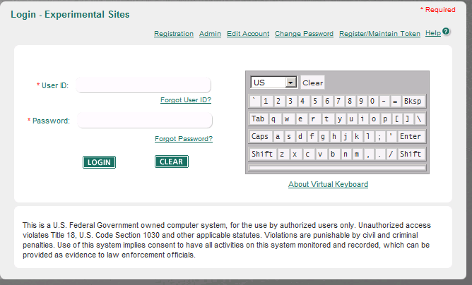
Figure 1 – Login Screen

From the login screen, click the “Registration” link found in the top navigation bar, first option (circled in red above). This loads the “Confirming Your Identity” screen (see Figure 2 on the next page).

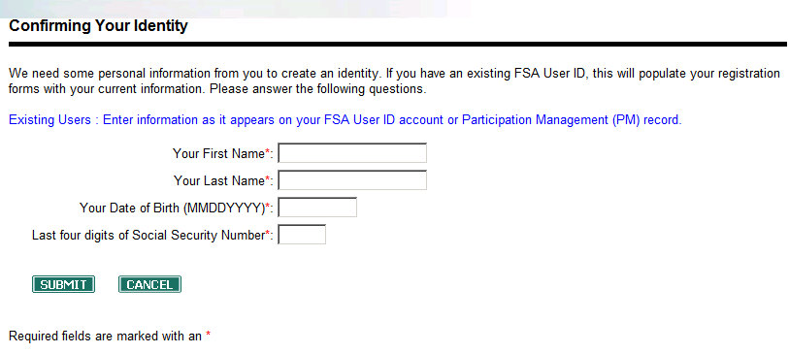
Figure 2 – Confirming Your Identity

The “Confirming Your Identity” screen is used to enter the four pieces of information that uniquely identify you from other Federal Student Aid SA users. Federal Student Aid uses this information to determine if you need to have a SA account created for you. If Federal Student Aid determines that you already have a SA account, Experimental Sites Data Collection Instrument access will be added to your existing account.

Enter your first name, last name, date of birth in MMDDYYYY format (e.g. December 1, 1970 would be 12011970), and the last four digits of your Social Security Number. Click the “Submit” button after you have entered your information. The screen will display a message informing you as to whether or not you have a current SA account. Figure 3 (shown on the next page) shows the message displayed if no SA account is found.
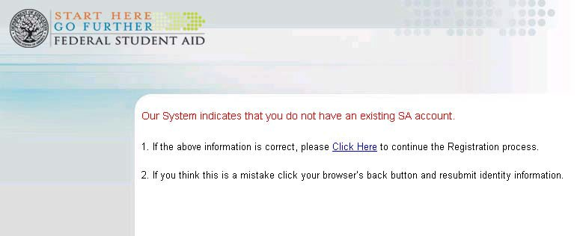
Figure 3 – No Security Architecture Account Found

Use the “Click Here” link to continue with registration. Clicking the link will load the
Demographic Information screen (Figures 4, 5 and 6).

If you have a valid SA account, the registration process will request that you login to continue registration. Once logged in, the Demographic Information screen will load (see below on next page).

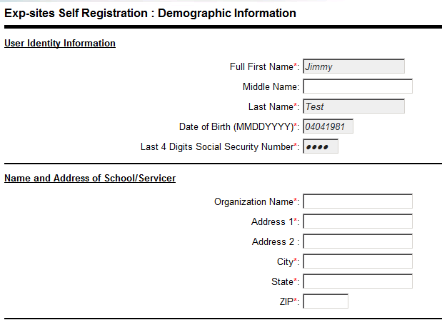
Figure 4 - Demographic Information Screen (Part 1)

Figure 4 (above) shows the section of the Demographic Information screen where a requestor can view (but not change) their user identity information and enter their organization’s name and address.

Figure 5 (on the following page) shows the section of the Demographic Information Screen where a requestor enters their work phone number, their work e-mail address, and their password. Password requirements are displayed on the screen.
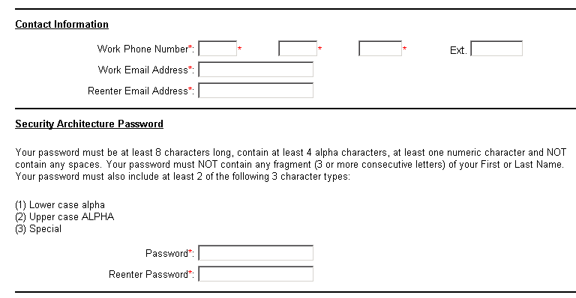
Figure 5 – Demographic Information Screen (Part 2)

Figure 6 (shown below) shows the section of the Demographic Information screen where a requestor enters their supervisor’s information and they set their challenge questions. Challenge questions are used to confirm the identity of a user in situations where the user has forgotten their password (see Section 6.2).

If you are registering and have an existing SA account, your challenge questions will have already been answered and thus the Challenge Questions section of the Demographic Information screen will not be displayed.
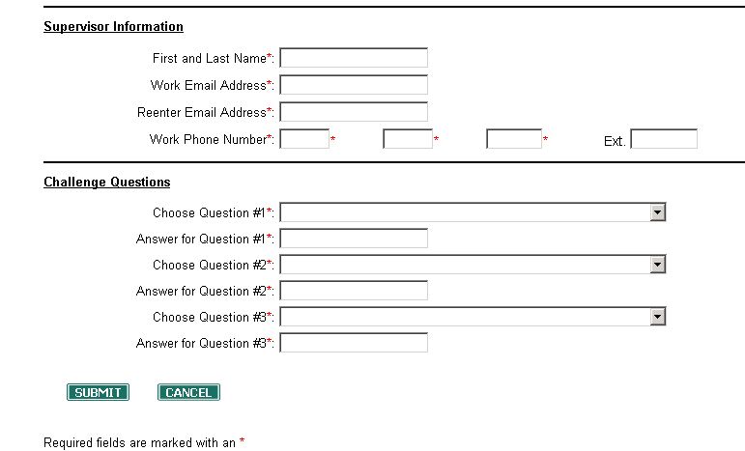
Figure 6 – Demographic Information Screen (Part 3)

After all demographic information has been entered, click the “Submit” button. If any errors are detected (i.e. required fields left blank, password not meeting requirements, etc.), the screen will reload and display the error messages at the top of the page. After all errors have been corrected, re-click the “Submit” button. If no errors are detected, the School Selection screen loads (see Figure 7).

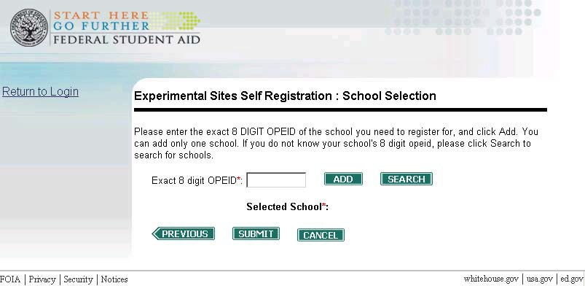
Figure 7 – School Selection Screen

The School Selection screen is used to pick the institution you are registering. Enter your school’s full 8 digit OPEID number and then click the ‘Add’ button. If the school you entered is participating in the Experimental Sites Initiative, the school’s name will be loaded (see Figure 9). If you enter an incorrect OPEID number, or the OPEID number of a school not participating in the Experimental Sites Initiative, a warning message will be displayed. If you do not know your school’s OPEID number, click the “Search” button. This will load the School Search screen (see Figure 8 on the next page).

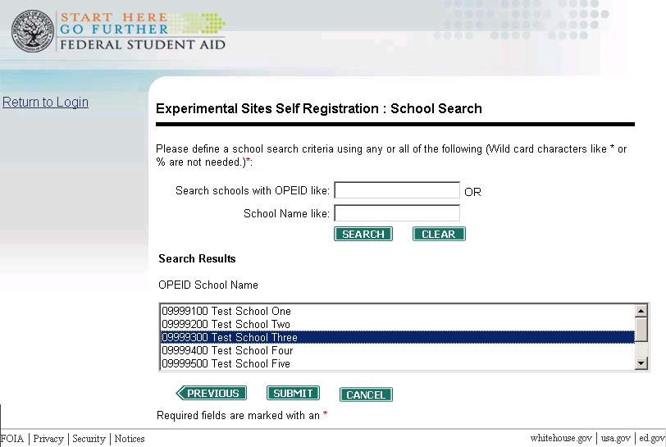
Figure 8 – School Search Screen

You can use the School Search screen to search for your institution using a partial OPEID number and/or partial school name. For example, if your school’s OPEID number was 09999200, you could search using 99. All schools with 99 in their OPEID number would then be displayed in the Search Results box towards the bottom of the page. Select your school from the list of search results or conduct a new search using different criteria.

Once you have found the correct school, click the “Submit” button. The School Selection screen, with the information about the school you picked, will load (see Figure 9 on the next page).

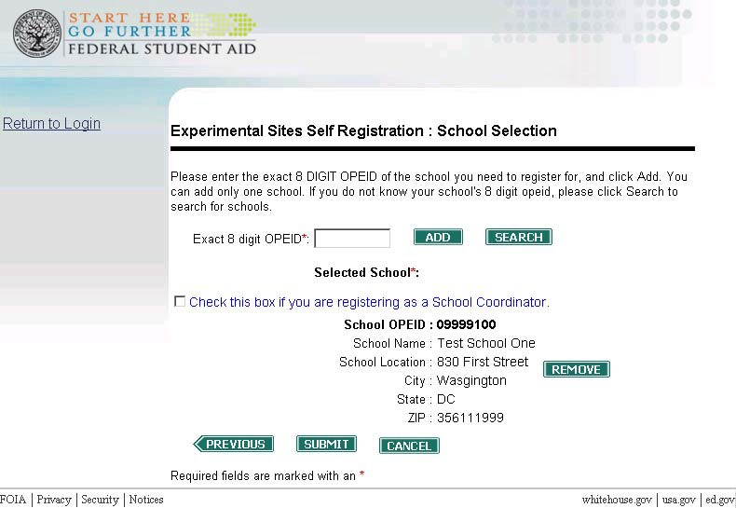
Figure 9 – School Selection Screen with Selected School Displayed

Figure 9 shows the school which you are requesting access. If it is the incorrect school, click the “Remove” button. This removes the selected school and allows you to add or search for a new school as described above. If you try to add or search for a second school, you will receive an error message stating that you can only register for access for one school. If you have problems locating your school, please contact the Experimental Sites Team (ExperimentalSites@ed.gov).

If the correct school is displayed, click the “Submit” button. The Confirm Entered Information screen loads. This screen displays the information entered during the registration process. If any information is incorrect, the “Modify” button can be used to correct the information.

The Confirm Entered Information screen also contains the Experimental Sites Data Collection Instrument’s rules of behavior (see Figure 10 on the next page). To register, you must read the rules of behavior and select the acknowledgement check box. This indicates that you have read and agree to follow the rules of behavior.

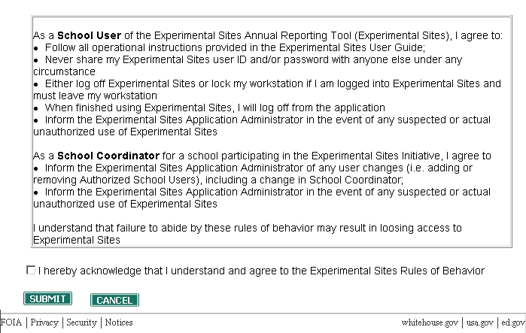
Figure 10 - Confirm Entered Information Screen, Rules of Behavior section

If everything is correct, click the “Submit” button. This submits your registration request to the school coordinator from the school you selected during the registration process. After the school coordinator has approved your request, you will receive an e-mail confirming your registration and a second e-mail containing your new SA User ID.

Note: Before registering as a school user, your school must have a registered school coordinator. If you attempt to register for a school that does not have a school coordinator, you will receive an error message. Section 5.1 provides more information on school coordinator registration.

5.1 School Coordinator Registration

The registration process for School Coordinator is almost identical to the process listed above, though there are three key differences.

First, after adding or searching for your school, you must select the checkbox labeled ‘Check this box if you are registering as a School Coordinator’ to register as a school coordinator (see Figure 9 on the previous page).

Second, registration requests from school coordinators are approved by the Experimental Sites Team. You will still receive an e-mail after your registration request has been approved and the second e-mail containing your new SA User ID.

Finally, you will receive an error message if you attempt to register as a school coordinator for a school that already has a registered school coordinator. If you receive this error message and believe this is in error, contact the Experimental Sites Team (ExperimentalSites@ed.gov).

5.2 Approving School User Access Requests

School Coordinators are responsible for approving/rejecting School User requests for their school. This process begins when the School Coordinator receives an e-mail informing them of a new request. To process the request, the School Coordinator must login to the Manage Users module. This begins by going to the Experimental Sites login screen. Once on the login screen, click the ‘Admin’ link on the top navigational bar next to Registration. This will load the School Coordinator Login screen (see figure 11).

Figure 11 – School Coordinator Login Screen

This screen is used by School Coordinators to access the screens used to approve/reject access requests and to manage approved users (see Section 5.3). Enter your User ID and password and then click the ‘Login’ button. If you provided the correct User ID and password, the Experimental Sites School Coordinator Home screen will load (see Figure 12 on the page below).
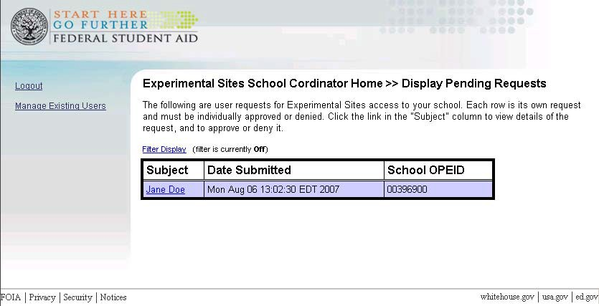
Figure 12 – Experimental Sites School Coordinator Home Screen

By default, this screen lists all pending access requests. Clicking on the requestor’s name will load the Request Detail screen. This screen lists the information provided by the requestor during the registration process. All information, except for the requestor’s password, last 4 Social Security Number digits, and security questions, are displayed on this screen.

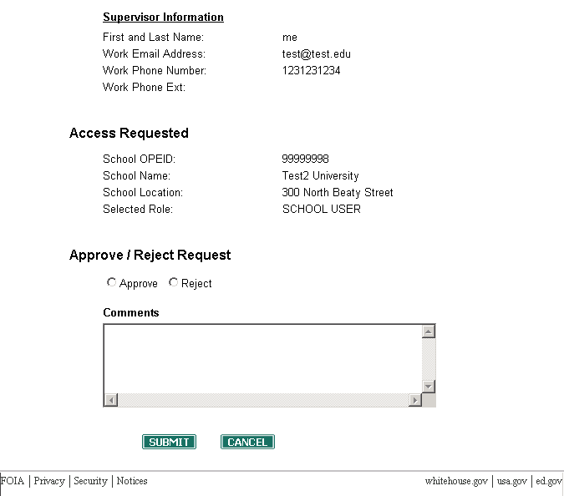
Figure 13 – Request Detail Screen (bottom half)

The bottom of the Request Detail Screen (see Figure 13 above) has a space to approve/reject the request. Select the radio button to the left of the desired action, enter any comments (optional) into the space provided and then click the ‘Submit’ button. The School Coordinator Home screen will load. The approved/rejected request will no longer be on the list of pending requests.

The requestor will receive an e-mail notifying them of the approval or rejection. The e-mail will also contain the comments entered on the Request Detail screen. If approved, the requestor will receive a second e-mail containing their SA User ID. Once they receive that e-mail, the approved requestor will be able to login to the Experimental Sites Data Collection Instrument.

5.3 Modifying a User’s Access

School Coordinators have the ability to view and to revoke user access to their school. To do so, login to the Experimental Sites School Coordinator Home screen (as described in Section 5.2). Once on the home screen, click the “Manage Existing Users” link (see Figure 12). This loads the Manage Existing Users screen (see Figure 14 on the page below).
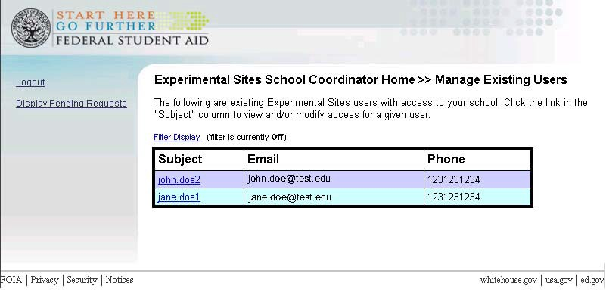
Figure 14 – Existing Users Screen

This lists all users from your school that have access to the Experimental Sites Data Collection Instrument. If you click on the user’s name, it will load the Existing User Detail screen (see Figure 15 on the page below). This screen lists the demographic information of the selected user. The user’s organization, contact information, and supervisor information is displayed.
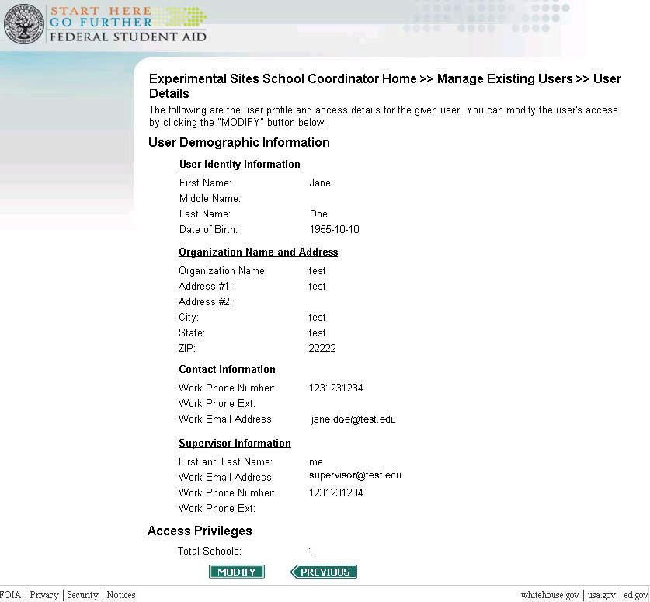
Figure 15 – Existing User Detail Screen

Use the “Previous” button to return to the Existing Users screen. To remove the selected user’s access to the Experimental Sites Data Collection Instrument, click the “Modify” button. This will load the Modify User Privileges screen (see Figure 16 on the page below).
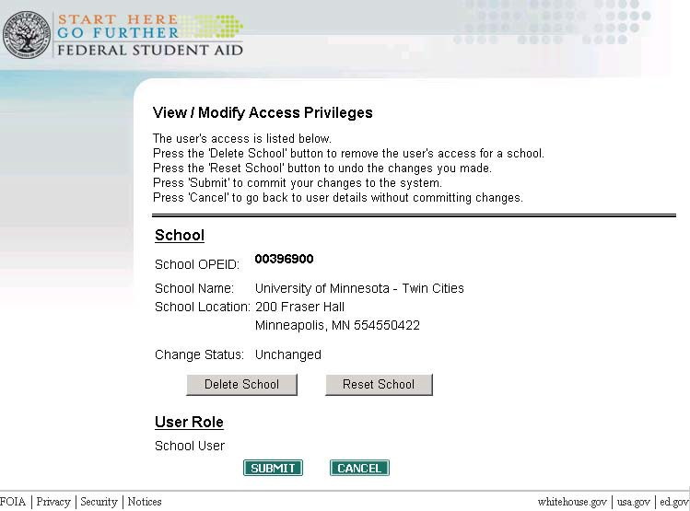
Figure 16 – Modify User’s Privileges Screen

The Modify User’s Privileges screen lists the selected user’s access. Clicking the “Delete School” button will update the “Change Status” field to “Pending Delete.” To confirm the removal of the user’s Experimental Sites access, click the “Submit” button. This will load the Existing Users screen. The selected user will no longer appear in the list of existing users and the user will not be able to login to the Experimental Sites Data Collection Instrument.

When the “Change Status” field says “Pending Delete” clicking the “Reset School” button will undo the pending deletion. Clicking the “Cancel” button before clicking the ‘Submit’ button will also undo the deletion.

6. Logging In

To log into the Experimental Sites Data Collection Instrument, click the “Data Collection Instrument” from the ESI Reporting box on the experimental sites website, https://experimentalsites.ed.gov. To prevent unauthorized access to the data collection instrument, the Federal Student Aid Login Screen will ask you to enter your User ID and password (see Figure 1). Once you enter your User ID and password, click “Submit.” The system will verify that you are a registered user and that you are authorized to access your school’s report. Once you have successfully logged in, your school’s report page will load (see Section 7).
The Federal Student Aid Login screen contains a warning message indicating that you are accessing and using a United States Government computer network. By logging in to the application you acknowledge that you have read and understand the warning message.

A feature of the Federal Student Aid Login screen is the virtual keyboard (see Figures 1 and 11). The virtual keyboard can be used to enter your User ID and password using your mouse instead of your keyboard. Virtual keyboard keys can be “pressed” by clicking them with your mouse or by hovering over the key with your mouse pointer for two seconds.

6.1 Changing Your Password

You can change your password at any time. To change your password, click the “Change Password” link on the Federal Student Aid Login Screen (see Figure 1, pg. 5). This will cause the Federal Student Aid Change Password Screen to load (see Figure 17). If you have recently been issued a temporary password, or if your password has expired, you will automatically be taken through this process.

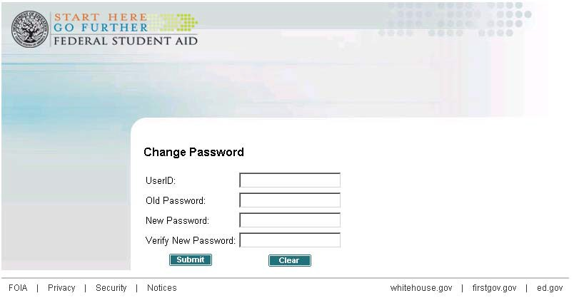
Figure 17 – Change Password Screen

Once at the Change Password screen, complete each of the four fields on the screen. Enter your current password into the “Old Password” field. Enter your new password into the “New Password” field. Re-enter your new password into the “Verify New Password Field.” The passwords entered in the “New Password” and “Verify New Password” fields must match. After all fields have been completed, click the “Submit” button.

The Password Change Success Screen will load (see Figure 18). Your password has now been successfully changed. Clicking the “Click here to Return” link returns you to the Experimental Sites home page. You can now log in using your User ID and your new password.

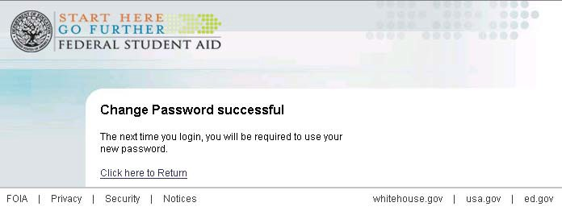
Figure 18 – Password Change Success Screen

6.2 Forgot Your User ID or Password

If you do not remember your User ID, please send an email to ExperimentalSites@ed.gov. You will be provided with your User ID via e-mail or phone.

If you forgot your password, you can retrieve it online. To retrieve your password online, access the Experimental Sites Data Collection Instrument as described in Section 3. Once the Federal Student Aid Login screen has loaded, click on the “Forgot Password” link. This loads a screen asking you for your SA User ID. Enter your User ID and click the “Submit” button. This loads the Federal Student Aid Challenge Screen (see Figure 19).

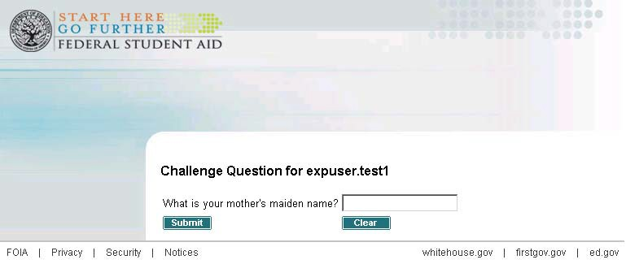
Figure 19 - Challenge Screen

The challenge screen will randomly present you with one of the challenge questions you entered during the registration process. Enter the answer to the question and click on the “Submit” button. This loads the Change Password screen shown in Figure 20 on the next page.

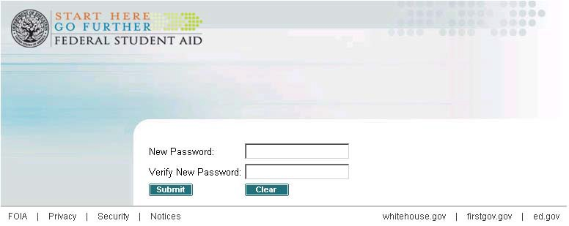
Figure 20 - Change Password Screen for Forgot Password

Enter and confirm your new password and then click the “Submit” button. Your password has been successfully updated. The Password Change Success Screen now loads (see Figure 18). Clicking the “Click here to Return” link returns you to the Experimental Sites home page. You can now log in using your User ID and your new password.

6.3 Expiring Passwords

User passwords will expire every 90 days. When your password expires, you will be prompted to change your password when you attempt to log in. Section 6.1 describes how to change your password.

6.4 Password Lock-Out

As a system security feature, the data collection instrument log in screen will allow only three failed login attempts before the system automatically locks your account. If you attempt to login with your account locked, the following message is displayed: “Account has been locked.”

Your account will remain locked for 30 minutes after your last login attempt. During this period, you will not be able to login to the Experimental Sites Data Collection Instrument. If you attempt to login during the 30 minute period, the countdown will reset. After 30 minutes, you can attempt to login again. If you do not remember your password, use the process described in Section 6.2 to reset your password.

If your account does not unlock after 30 minutes, send an email to ExperimentalSites@ed.gov for assistance. You will be provided a new temporary password via e- mail. You will be prompted to change your password after logging in with the temporary password.

7. Annual Report Home Page

After you login, the user will be taken to the Privacy Act page. The user should read the Privacy Act information and click Continue. The user will then be taken to the Rules of Behavior screen. Read the information listed and scroll to the bottom and select the check box acknowledging receipt and understanding of the Rules of Behavior and click Accept. The Home Page lists the experiment(s) that you participated in for the previous award year.

8. Accessing Worksheets

Click on Start/Continue Survey to begin entering data and complete your reporting requirement. The user will also be able to view the status of their submission. If you need to review data you entered previously please contact the Experimental Sites Team (ExperimentalSites@ed.gov).

9. Entering Worksheet Data

Once you open a worksheet page, the user will be taken to the first question for the experiment they selected. When the user has completed entry for the first question you can click, Next, Save and Exit or Save Without Exit. NOTE: Once the user clicks Next to advance to the next page the subsequent question must be entered. If you are not ready to answer the next question the user should select Save and Exit.

After you have completed the first question and clicked Next you will be taken to question 2. There you will have the same navigational options as well as an option to return to the previous page. NOTE: You are required to complete the information on that page before navigating to the Previous or Next page.

When completing the worksheets, there are several data elements that have specific range, sum, and/or cross-edit check requirements. You will be alerted when you have entered incorrect information.

For a more detailed explanation of the questions on the worksheet please review the Data Dictionary in the appendix starting on page 25.

10. Timeouts

The Experimental Sites data collection instrument will “timeout” your session if there has been no activity for 30 minutes. Inactivity means that the server has not been accessed for 30 minutes (i.e., you may have been typing in a worksheet, but if you have not saved or opened a new worksheet during the 30 minutes, you will be timed-out). Please note that if you are timed-out, you will lose any changes that were made since you last saved. For your security, we must ask you to log in again. Simply log in by entering your User ID and password. It is imperative that you save the data entered if you need to research a question, leave your desk, etc.

11. Saving Worksheet Data

As previously mentioned you can Save data at any time by clicking the Save and Exit button. However, you will not be able to submit the report. This functionality has changed from previous years when you could not save if data had not been entered on the entire worksheet. This has now been resolved.

12. Submitting Your Completed Report

Once you have completed all of your school’s worksheets, you will be returned to the Home page where you will find a link to Submit the survey. You will also notice that the status of your survey has changed from Started to Completed.

IMPORTANT NOTE: Once your report is submitted, you will NOT be able to make any additional changes, or edit the report or the worksheets. As a result, it is important that you make sure that all data elements are final before submitting your report. You will be able to print your report and individual worksheets after the report is submitted (see Section 13 for additional details on printing). If you determine that you need to make additional changes to your submitted report, send an email to ExperimentalSites@ed.gov. The Experimental Sites team will then unlock your submitted report, so that you can make any revisions.

13. Printing Your Worksheets

You can print your worksheets by experiment. To print your worksheets, open the worksheet by clicking View Survey. The information that you have entered will then appear. You will print this information as you would when printing any webpage. For example, using Internet Explorer you will click File and Print. NOTE: It is highly recommended that you select Print Preview before printing to determine the length and format of the document you are printing.

14. Logging Off / Exiting the Data Collection Instrument

You can exit the Experimental Sites Data Collection Instrument at any time by clicking “Exit” in the main tool bar. You will then exit the tool and be sent to the Experimental Sites home page. You can then close your browser or navigate to another site.

If you return to the Experimental Sites Data Collection Instrument within 30 minutes of leaving during the same browser session (i.e. you do not close your browser window and open a new window) you will be able to directly access the Experimental Sites Data Collection Instrument without logging in again. Closing your browser window after exiting will fully log you off.

15. Contact Us

The Contact Us page provides you with contact information for assistance/questions in completing your reporting requirement. To access the Contact Us page, click the “Contact Us” button on the main tool bar. The contact information provided can also be used to let us know what you think about using the data collection instrument and if there are ways that we can improve our service.

16. Privacy

Information about the Department of Education’s privacy policies can be found by clicking on the “Privacy” link found in the footer of any page. Clicking the “Privacy” link will load the Department of Education’s Privacy Policy page.

17. Questions/Contacts

If you have any questions on completing your annual report or on using the data collection instrument, please send an email to ExperimentalSites@ed.gov.

Appendix: Data Dictionary

Below are screen shots from our test environment for the Reduced Unsubsidized Loan Experiment. Following each screen shot, we provide a short description of each data element requested. These describe the data your school needs to report during this reporting period and how to report it. If you have any questions about the information below please send an email to ExperimentalSites@ed.gov.

Experiment 6 – Reduced Unsubsidized Loan Experiment
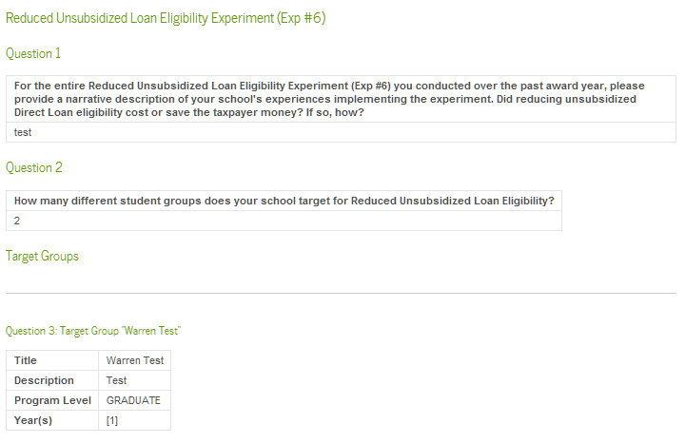
Question 1 asks for a narrative description of your school’s experince and is limited to 4,000 characters.
Question 2 asks for the number of groups (reasons) your school allows limiting unsubsidized loans. Note: any group that contains BOTH undergraduate and graduate students needs to be reported as TWO groups.
Question 3 requests a title and descrption for each group. Additional information is requested for each group defined in Question 3. This year we added the functionality that allows you to delete and add target groups.
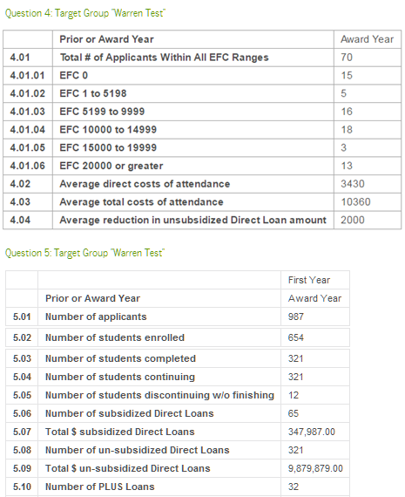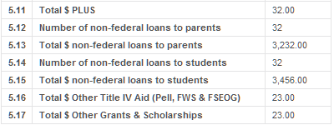
Question 4 requests information for the entire targeted group.
First, it asks for counts by EFC range (4.01.01 through 4.01.06). Note that item 4.01 “Total # of Applicants Within All EFC ranges” is calculated based on entries to sub items 4.01.01 through 4.01.06. The system will not allow direct entry of item 4.01.
4.02 Average direct cost of attendance – tuition and required fees
4.03 Average total cost of attendance – direct costs plus room, board, travel allowance, etc.
4.04 Average reduction in unsubsized Direct Loan amount– Provide the average amount unsubsized Direct Loans were reduced across all borrowers meeting this school criteria.
Question 5 requests information disaggregated (reported separately) by year in school. Therefore there will be a separate column for data entry for each year you indicated applied to each group.
5.01 Number of Applicants – provide the total number applicants from the indicated year(s). Unlike item 4.01, 5.01 will NOT be automatically calculated, but like 4.01 should equal the sum of its components 5.01.A through 5.01.D.
5.01.A Dependent Pell Eligible – provide the number of dependent Pell Grant eligible applicants for the year in school indicated by the column.
5.01.B Dependent Pell Ineligible – provide the number of dependent Pell Grant ineligible applicants for the year in school indicated by the column.
5.01.C Independent Pell Eligible – provide the number of independent Pell Grant eligible applicants for the year in school indicated by the column.
5.01.D Independent Pell Ineligible – provide the number of independent Pell Grant eligible applicants for the year in school indicated by the column.
5.02 Number of Students Enrolled – provide the total number enrolled from the indicated year(s).Unlike item 4.01, 5.02 will NOT be automatically calculated, but like 4.01 should equal the sum of its components 5.02.A through 5.02.D.
5.02.A Dependent Pell Eligible – provide the number of dependent Pell Grant eligible enrolled students for the year in school indicated by the column.
5.02.B Dependent Pell Ineligible – provide the number of dependent Pell Grant ineligible enrolled students for the year in school indicated by the column.
5.02.C Independent Pell Eligible – provide the number of independent Pell Grant eligible enrolled students for the year in school indicated by the column.
5.02.D Independent Pell Ineligible – provide the number of independent Pell Grant enrolled students for the year in school indicated by the column.
5.03 Number of students completed – provide the number of students enrolled in the indicated year(s) who completed their program during the award year. Note items 5.03, 5.04, and 5.05 are mutually exclusive and exhaustive; they should sum to 5.02.
5.04 Number of students continuing – provide the number of students enrolled in the indicated year(s) who returned the following award year to continue their program of study. . Note items 5.03, 5.04, and 5.05 are mutually exclusive and exhaustive; they should sum to 5.02.
5.05 Number of students discontinuing w/o finishing – provide the number of students enrolled in the indicated year(s) who did NOT continue their program of study the following year. Note items 5.03, 5.04, and 5.05 are mutually exclusive and exhaustive; they should sum to 5.02.
5.06 Number of subsidized Direct Loans – number of students borrowing money through the subsidized Direct Loan program during the indicated award year.
5.07 Total $ subsidized Direct Loans – total dollar amount of subsidized Direct Loans disbursed during the indicated award year.
5.08 Number of unsubsidized Direct Loans – number of students borrowing money through the unsubsidized Direct Loan program during the indicated award year.
5.09 Total $ unsubsidized Direct Loans – total dollar amount of unsubsidized Direct Loans disbursed during the indicated award year.
5.10 Number of PLUS Loans – number of (parents of) students borrowing money through the PLUS Loan program during the indicated award year.
5.11 Total $ unsubsidized Direct Loans – total dollar amount of PLUS Loans disbursed during the indicated award year.
5.12 Number of non-federal loans to parents – number of loans certified for parents of students in the indicated group during the indicated award year.
5.13 Total $ non-federal loans to parents – total dollar amount of loans certified for parents of students in the indicated group during the indicated award year.
5.14 Number of non-federal loans to students – number of loans certified for students in the indicated group during the indicated award year.
5.15 Total $ non-federal loans to students – total dollar amount of loans certified for students in the indicated group during the indicated award year.
5.16 Total $ other Title IV aid (Pell, FWS, FSEOG) – total dollar amount of other Title IV aid made to students in the indicated group during indicated award year.
5.16 Total $ other Grants & Scholarships – total dollar amount of non-federal grants or scholarships awarded to students in the indicated group during indicated award year.

